Communicating

with patients

Version 1.0 | 15/05/2020
Version 2.0 | 16/06/2020

Communicating with patients
Communicating with and reassuring patients cannot be underestimated, and a consistent message should be formulated to include what the practice is doing to prevent transmission and protect patients. Make it clear that their dental needs are important, but their overall health and wellbeing is also paramount.

A variety of methods can be used to let patients know you are open again including telephone calls, text messages, emails, practice website, social media channels etc. It is important to inform them of any new protocols and procedures in place so that they can be prepared when they attend. This will help to boost their confidence levels too.

Example of a “We are open” letter or email
View an editable version of the letter below here

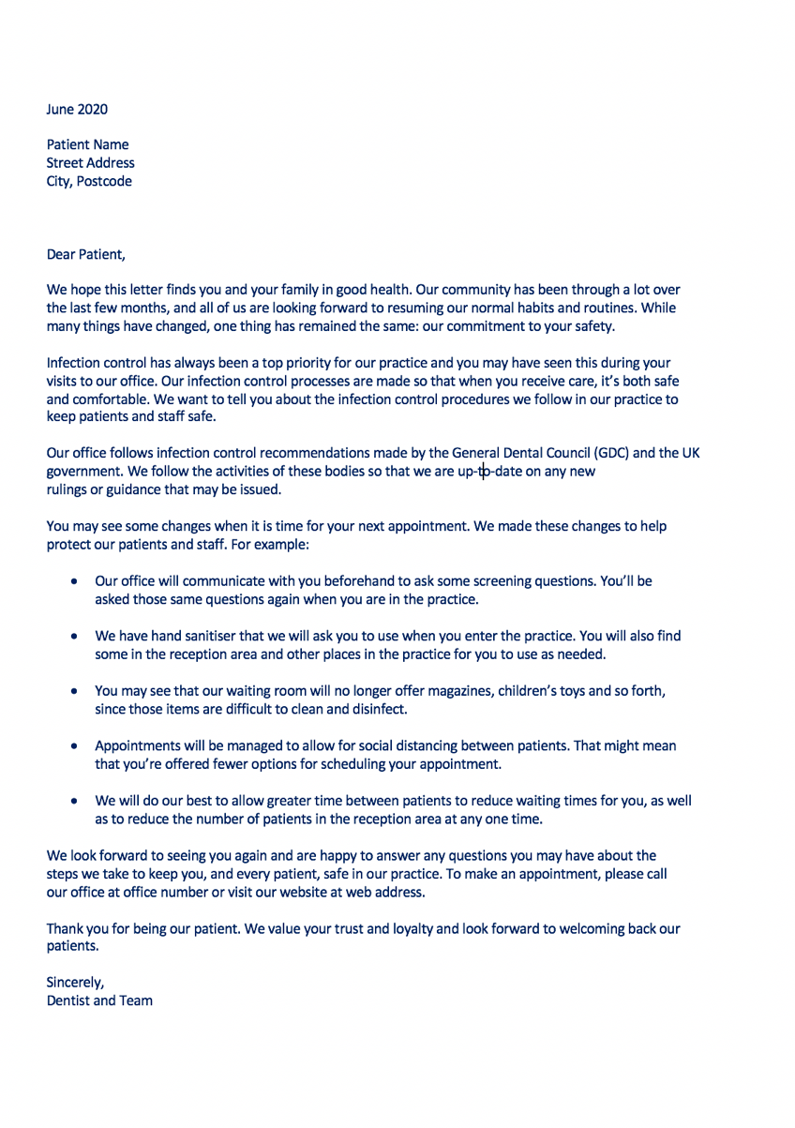

Pre-Appointment

Pre-appointment preparation is essential in providing safe care, ensuring patients are well informed and suitably prepared ahead of their visit to the dental practice. Communication is central to mitigating risk and establishing expectations of how and what dentistry can be delivered within the limitations of the pandemic. (FGDPUK Implications of COVID-19 for the safe management of general dental practice A practical guide)

- Remote contact should be made with all patients prior to appointments at the dental practice, video consultations are preferred, where this is not possible telephone calls will be sufficient
- Patient information communicated via practice website
- Relevant information/forms/admin tasks emailed to patient ahead of appointment - Patient questionnaire, COVID Screening, Medical history, Patient forms – FP17, estimate, consent, Information on payment
- Consider communication barriers and how to overcome these
- Patient health risk assessment
- Follow up call with patients 14 days after appointment to check that they have not since developed COVID-19 symptoms
- Consider asking the patient to bring their own pens

* For all remote points of contact, General Data Protection Regulations (GDPR) must be followed as per current guidelines during the pandemic

Practice signage
Having visual reminders around your practice will help patients and staff feel re-assured and serve as a reminder of best practice.

Examples of wording that could be used on new practice signage:

- Please respect 2 metre social distancing
- Please use this hand sanitiser
- Please adhere to social distancing measures – 2 metres
- Do not enter the reception area if there is a patient present
- Do not enter
- Please follow the arrows in place
- Surgery in use
- AGP Surgery
- Non AGP Surgery
- Catch it, bin it, kill it
- Handwash diagram

Visual examples of new practice signage:

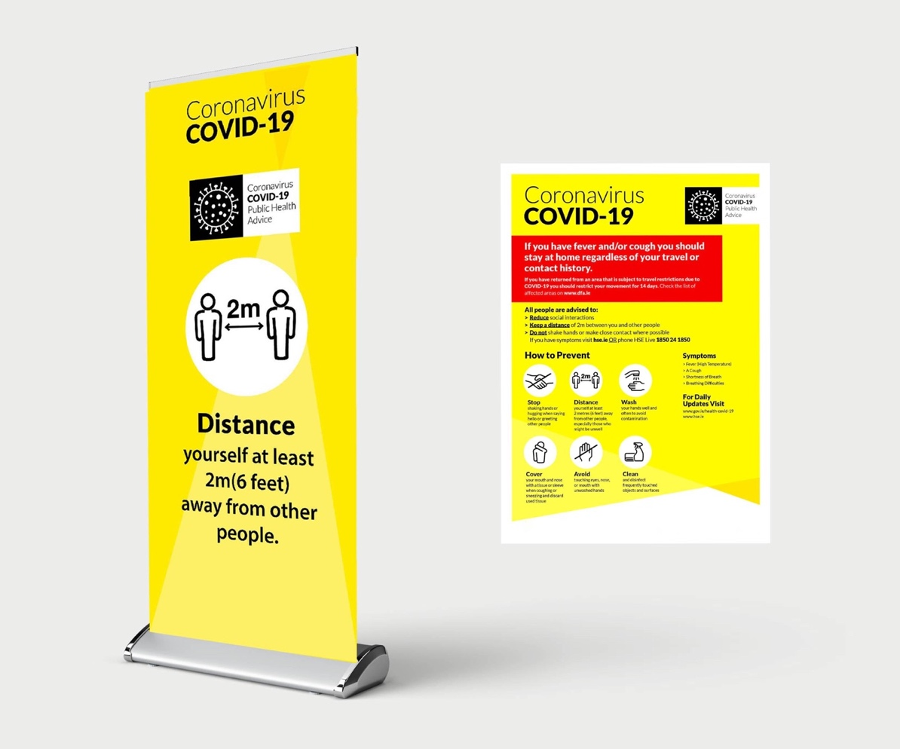

Further information can be found at:

https://www.england.nhs.uk/coronavirus/wp-content/uploads/sites/52/2020/06/C0575-dental-transition-to-recovery-sop-4-June.pdf

https://www.fgdp.org.uk/implications-covid-19-safe-management-general-dental-practice-practical-guide

https://www.gdc-uk.org/docs/default-source/guidance-documents/high-level-principles-remote-consultations-and-prescribing.pdf

https://www.fgdp.org.uk/news/covid-19-latest-guidance-and-resources-gdps

http://www.sdcep.org.uk/published-guidance/covid-19-practice-recovery/

https://bda.org/advice/Coronavirus/Pages/returning-to-work.aspx

https://bda.org/login?ReturnUrl=%2fadvice%2fba%2f_layouts%2f15%2fAuthenticate.aspx%3fSource%3d%252Fadvice%252Fba%252FDocuments%252Freturning%252Dto%252Dwork%252Dtoolkit%252Epdf&Source=%2Fadvice%2Fba%2FDocuments%2Freturning-to-work-toolkit.pdf

