Considerations for staffing and new pattern of workflow

Version 1.0 | 15/05/2020
Version 2.0 | 16/06/2020

Considerations for staffing and new pattern of workflow

Staffing
- Staffing numbers should be minimised in order to allow for adequate social distancing where appropriate.
- Ensure all staff are inducted into the new ways of working (see separate document: Staff induction for reopening)
- As few staff members as possible should be allocated to see patients. Each staff member should have a specific designated role for example:
- Treating dentist
- Assisting nurse in surgery providing patient care and support with the dentist
- A nurse outside the surgery, to help with passing required instruments and materials into the surgery and assist with donning and doffing of PPE
- A further nurse outside the surgery, to develop radiographs, retrieve emergency drugs if necessary, retrieve any equipment or materials outside of the surgery and escort patients in and out.
- Individual risk assessment completed for each staff member
- When completing a risk assessment consider household contact, staff who are shielding, those at increased risk
- Cleaning staff must also complete full induction, training and instruction and have a risk assessment completed
- Extremely vulnerable staff members should not be returning to work
- Staff displaying any COVID-19 symptoms or living in a household with someone who displays symptoms must not come to work, self-isolate isolate and request a test from .GOV UK website
https://www.gov.uk/guidance/nhs-test-and-trace-how-it-works

Staff Uniform
- Staff must not travel to and from the practice in clinical clothing/uniform – including reception/admin staff.
- Assign a designated changing area where possible.
- When arriving at the practice, “home clothes” should be placed into a separate bag or pillowcase.
- No jewellery should be worn, bare to the elbow is required to enable hand washing (long sleeved gowns will cover this area when required), and hair should be tied back.
- The use of full gowns in high risk situations will protect scrubs worn under the gown, therefore, it will not be necessary to change scrubs between sessions in one day
- At the end of the day, clinical clothing including shoes should be removed. Clothes should be placed straight into a plastic bag or washable bag/pillowcase. Footwear should be made of a wipe clean material and cleaned at the end of each day and should remain on site. Wear “home shoes” and “home clothes” to go home.
- Appropriate hand washing should be carried out following the removal of clinical clothing.

- Upon, arriving home, the clinical clothing should be placed straight into the washing machine and the bag disposed of or the washable bag placed into the washing machine with the clothing. Do not mix with other household laundry and launder at the highest possible temperature. The washing
machine should be half of a full load allowance. Hand washing should be completed following completion of this.
- Showering and washing hair as soon as possible is recommended.
- Wiping down the washing machine after the load is complete and removed is recommended.
Workflow
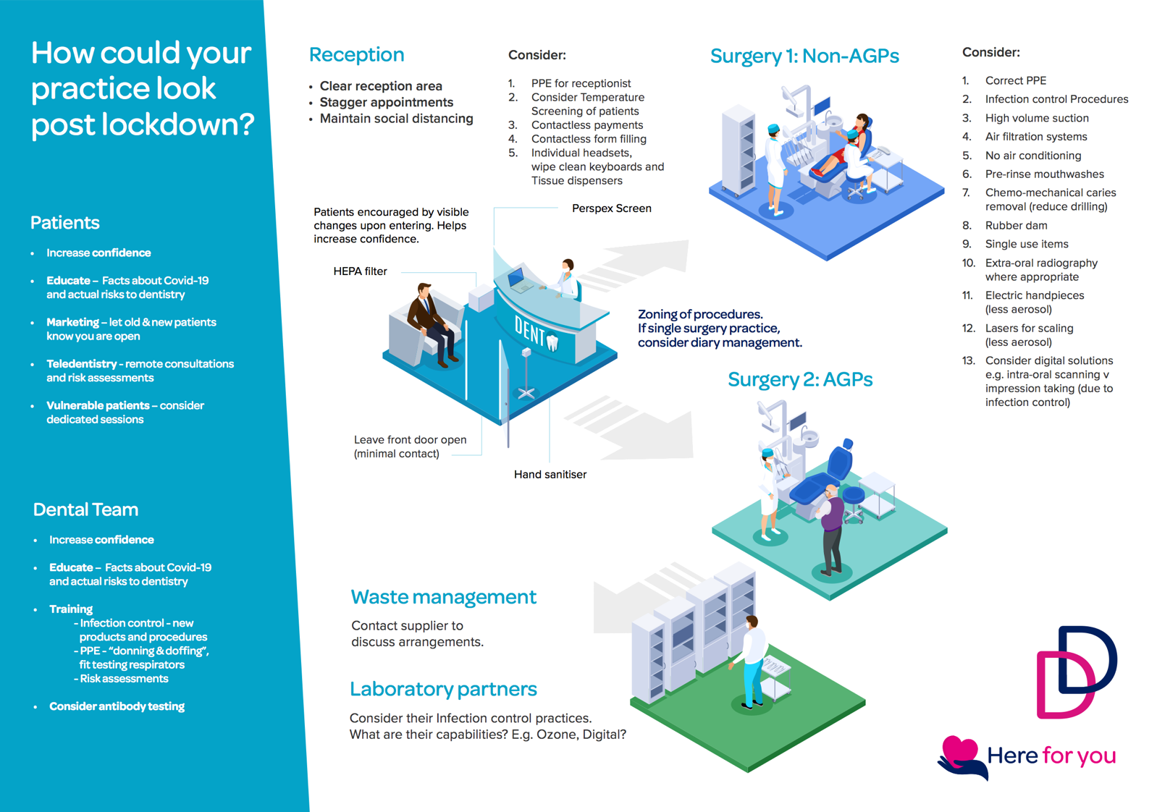

Waiting Area/Reception

- All patients attending the practice need to be asked the current COVID-19 screening questions on entry, referral protocol in place for patients displaying signs/symptoms of COVID-19 who require urgent dental treatment/care
- Alternative arrangements will need to be available to accommodate any patient who is unable to attend alone or complete any paperwork prior to attendance

- A risk assessment of patients with mobility issues should be undertaken to minimise the possibility of falls and contamination from, or of, their mobility device.
- Limit the number of patients entering the practice at any one time.
- Appointments should be carefully scheduled to ensure that, depending on waiting room size, only 1 patient is present in the waiting room at any one time. Should a larger waiting area be present then seating must be positioned to ensure social distancing is adhered to.
- Consider the entrance to the waiting area to ensure that patients are not passing other patients when entering the area.
- Where possible, designate a separate entrance/exit for staff and patients.
- Where possible, a patient should go straight to the surgery and not utilise the waiting area at all.
- Patients should be informed to arrive only a few minutes before their allocated appointment time to prevent unnecessary waiting times and again reduce the number of patients present at any one time. Consider asking patients to remain in their car until they are informed to enter (via a phone call or text message).
- Where possible entrance doors/doors to waiting areas should remain open to reduce contact with door handles.
- Patients’ temperatures should be checked using non-contact thermometers.
- Chairs within the waiting room must be made of wipe clean material (and be regularly cleaned between patients).
- Consider appropriate signage to inform patients of new protocols e.g. to only enter the reception area if no other patients are present.
- Hand sanitisers should be present at the entrance and exit door and in the waiting room/reception areas.
- Respiratory/cough hygiene should be observed by all staff/patients/carers. Disposable tissues should be present to cover the nose and mouth when sneezing, coughing or wiping the nose, ‘Catch it, Bin it, Kill it’.
- Consider placing markings on the floor to indicate safe distance locations.
- Consider entrance and exit routes to minimise cross-over of patients and staff.
- All magazines, leaflets, plants, literature, children’s toys etc to be removed from waiting and reception areas.
- Water dispensers/refreshment provisions to be removed.
- Patients should attend the practice by themselves where possible, patient escorts should be asked to wait outside the building wherever possible.
- Consider consent protocols to be obtained at reception and then the parent/guardian can be asked to wait outside. Clinical judgement needs to be exercised as to what is appropriate.
- The use of prams/pushchairs to be avoided where possible.
- Advise patients to only bring necessary items into the practice e.g. no shopping bags.
- Designated area for coats, bags etc
- Contactless payment options where possible.
- Where pens need to be used, have a designated pen for patients that is wiped after each patient use.
- Encourage online form filling where possible prior to appointments. These can be discussed during remote consultations e.g. medical history forms.
- Email treatment plans where possible.
- Receipts to emailed to the patient where required.

- The use of safety screens to be considered at the reception desks, where these are not installed surgical masks and visors to be provided
- PPE available for reception staff
- Time spent at reception should be kept to a minimum.
- Information of measures in place communicated to patients via the website and prior to appointments.
- Consider air filtration/purification systems in reception and waiting areas.
- Regular cleaning of the waiting and reception area
- Windows should remain open where possible.
- Avoid shaking hands with patients

Toilet facilities
- Advise patients to use the bathroom before setting off for their appointment – the practice toilet should only be used by patients when necessary.
- If possible, lock the patient toilet door from the outside so patients cannot enter without letting a staff member know. This will enable planning of cleaning where required.
- Where possible, separate toilet facilities should be allocated for staff and patients.
- Hand washing notices should be displayed near the sink.
- Sufficient hand washing and hand drying products should be made available.
- Do not use hand dryers or re-usable towels, disposable alternatives should be available.
- Encourage patients to inform you when using the facilities to ensure they are accounted for in the number of patients present at one time and to reduce the risk of patients passing this area whilst the patient is exiting the facilities.
- Only required items should be present in the toilet facilities.
- Door handles/door locks should be cleaned following use. Consider cleaning other areas of the facilities too.

Dedicated surgeries
- If more than one surgery is available, designate certain surgeries for AGPs and surgeries for Non- AGPs
- Where only one surgery is present, designate certain times for vulnerable patients, AGPs and Non-AGPs
- Ideally plans should include the use of multiple treatment rooms, in order to allow any aerosol to settle between patients, and alternating rooms between patients.
- Display signage to clearly identify those surgeries used for AGPs and Non-AGPs and to identify when surgeries are ‘occupied’ or ‘in use’.
- Limit the number of staff accessing surgeries.
- Chaperones should only enter surgeries where necessary.
- Patients should be escorted to the surgery to ensure the they follow the correct route.
- Keep windows open where possible. Keep surgery doors closed.
- Designated staff for each surgery – staff to remain working in the same surgery for the working day
- Cleaning protocols should be adhered to and updates monitored and communicated.
- Hand hygiene protocols and techniques should be adhered to.

- PPE protocols should be followed, and the correct PPE should be available in sufficient quantities.
- Designate areas, outside of the surgery, for the ‘donning’ and ‘doffing’ of PPE, where space is limited, the ‘donning’ of PPE could be done in a clean surgery prior to patient arrival.
- Following AGPs, PPE must be removed within the surgery apart from the mask, this should be removed in the designated ‘doffing ‘area
- Waste management should be considered, liaise with contracted waste provider to discuss, increased frequency of collection may be required.
- Air filtration/purification systems could be considered.

Vulnerable Patients
Examples of higher risk individuals include:
- Patients over a certain age (70+)
- People with underlying health conditions that put them at increased risk
- Pregnant women
- People living in institutions (e.g. residential care and prisons)

Consider designated time slots for such patients, morning appointments may be preferred. Consider the following principles:

- Allocate sufficient time in between each patient (https://www.gov.uk/government/publications/wuhan-novel-coronavirus-infection-prevention-and-control/transmission-characteristics-and-principles-of-infection-prevention-and-control)
- Carry out recommended decontamination procedures before and after care as appropriate to minimise the risk (https://www.gov.uk/government/publications/decontamination-in-primary-care-dental-practices)
- Manage social distancing appropriately (https://www.gov.uk/government/publications/covid-19-guidance-on-social-distancing-and-for-vulnerable-people/guidance-on-social-distancing-for-everyone-in-the-uk-and-protecting-older-people-and-vulnerable-adults)

References

https://www.fom.ac.uk/wp-content/uploads/Risk-Reduction-Framework-for-NHS-staff-atrisk-of-COVID-19-infection-12-05-20.pdf

https://www.gov.uk/guidance/nhs-test-and-trace-how-it-works

https://www.england.nhs.uk/coronavirus/wp-content/uploads/sites/52/2020/06/C0575-dental-transition-to-recovery-sop-4-June.pdf

https://www.fgdp.org.uk/implications-covid-19-safe-management-general-dental-practice-practical-guide

https://bda.org/login?ReturnUrl=%2fadvice%2fba%2f_layouts%2f15%2fAuthenticate.aspx%3fSource%3d%252Fadvice%252Fba%252FDocuments%252Freturning%252Dto%252Dwork%252Dtoolkit%252Epdf&Source=%2Fadvice%2Fba%2FDocuments%2Freturning-to-work-toolkit.pdf

https://www.gov.uk/government/publications/decontamination-in-primary-care-dental-practices

https://www.england.nhs.uk/coronavirus/wp-content/uploads/sites/52/2020/04/C0282-covid-19-urgent-dental-care-sop.pdf

https://www.nice.org.uk/guidance/cg139

https://assets.publishing.service.gov.uk/government/uploads/system/uploads/attachment_data/file/449049/Code_of_practice_280715_acc.pdf

https://assets.publishing.service.gov.uk/government/uploads/system/uploads/attachment_data/file/170689/HTM_01-05_2013.pdf

http://www.sdcep.org.uk/published-guidance/covid-19-practice-recovery/

https://bda.org/advice/Coronavirus/Pages/returning-to-work.aspx

https://www.england.nhs.uk/wp-content/uploads/2020/04/Uniforms-and-Workwear-Guidance-2-April-2020.pdf

https://assets.publishing.service.gov.uk/government/uploads/system/uploads/attachment_data/file/449049/Code_of_practice_280715_acc.pdf

https://bda.org/advice/Coronavirus/Documents/Staying%20safe%20poster.pdf

https://www.rcog.org.uk/en/guidelines-research-services/guidelines/coronaviruspregnancy/covid-19-virus-infection-and-pregnancy/

