Considerations for RIDDOR Reporting COVID-19

Considerations for RIDDOR Reporting COVID-19

A report under RIDDOR (The Reporting of Injuries, Diseases and Dangerous Occurrences Regulations 2013) will only apply when:

- an unintended incident at work has led to someone’s possible or actual exposure to coronavirus. This must be reported as a dangerous occurrence.
- a worker has been diagnosed as having COVID 19 and there is reasonable evidence that it was caused by exposure at work. This must be reported as a case of disease.
- a worker dies as a result of occupational exposure to coronavirus.

What to report

Dangerous occurrences
If something happens at work which results in (or could result in) the release or escape of coronavirus, you must report this as a dangerous occurrence. An example of a dangerous occurrence would be a lab worker accidentally smashing a glass vial containing coronavirus, leading to people being exposed.

Within a dental practice the main concern is the AGP-Aerosol Generating Procedure and potential transmission risk of Covid 19. Further guidance is available via:

- https://www.gov.uk/government/publications/decontamination-in-primary-care-dental-practices
- https://www.england.nhs.uk/coronavirus/wp-content/uploads/sites/52/2020/04/C0282-covid-19- urgent-dental-care-sop.pdf
- https://www.gov.uk/government/publications/wuhan-novel-coronavirus-infection-prevention-and-control/transmission-characteristics-and-principles-of-infection-prevention-and-control

Further guidance is available via: http://www.legislation.gov.uk/uksi/2013/1471/schedule/2/made

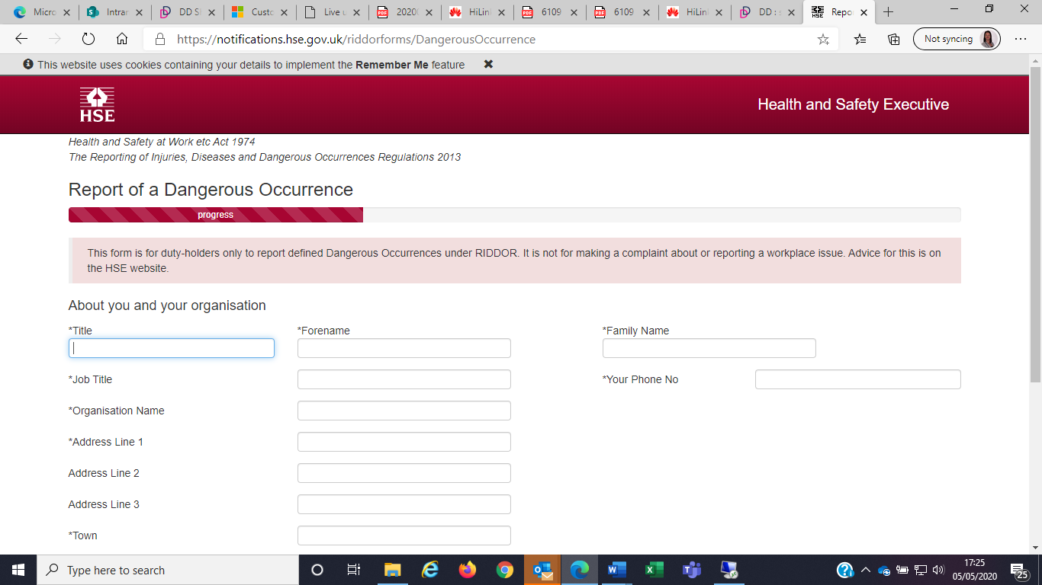

Cases of disease: exposure to a biological agent
If there is reasonable evidence that someone diagnosed with COVID-19 was likely exposed because of their work, you must report this as an exposure to a biological agent using the case of disease report. An example of a work-related exposure to coronavirus would be a health care professional who is diagnosed with COVID-19 after treating patients with COVID-19.

Further guidance is available via: http://www.legislation.gov.uk/uksi/2013/1471/regulation/9/made

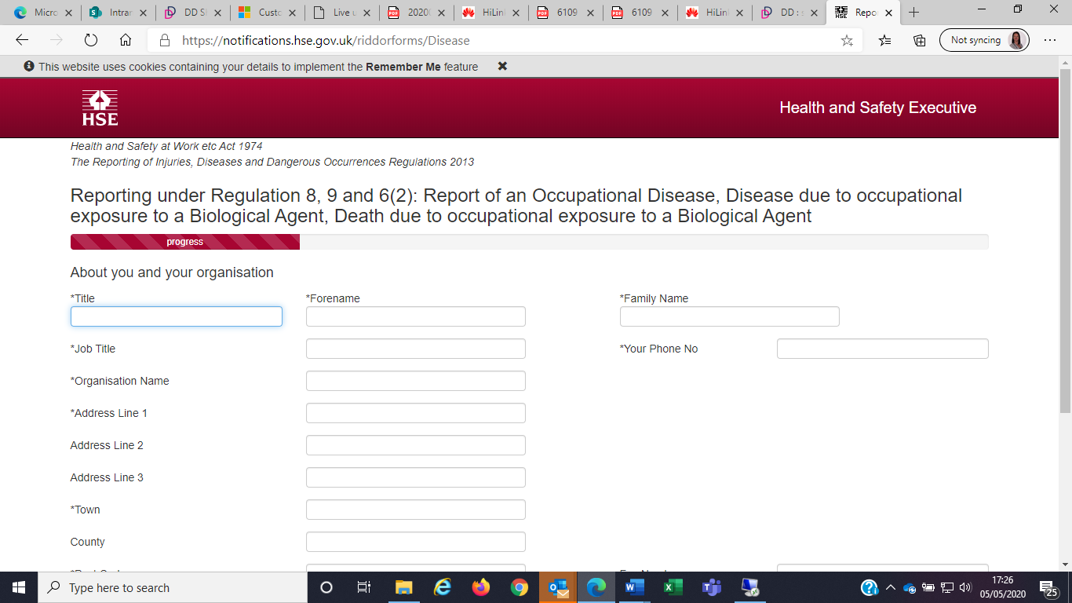

Work related fatalities
If a worker dies as a result of exposure to coronavirus from their work and this is confirmed as the likely cause of death by a registered healthcare practitioner, then you must report this as a death due to exposure to a biological agent using the ‘case of disease’ report form. You must report workplace fatalities to HSE by the quickest practicable means without delay and send a report of that fatality within 10 days of the incident.

Further guidance is available via: http://www.legislation.gov.uk/uksi/2013/1471/regulation/6/made

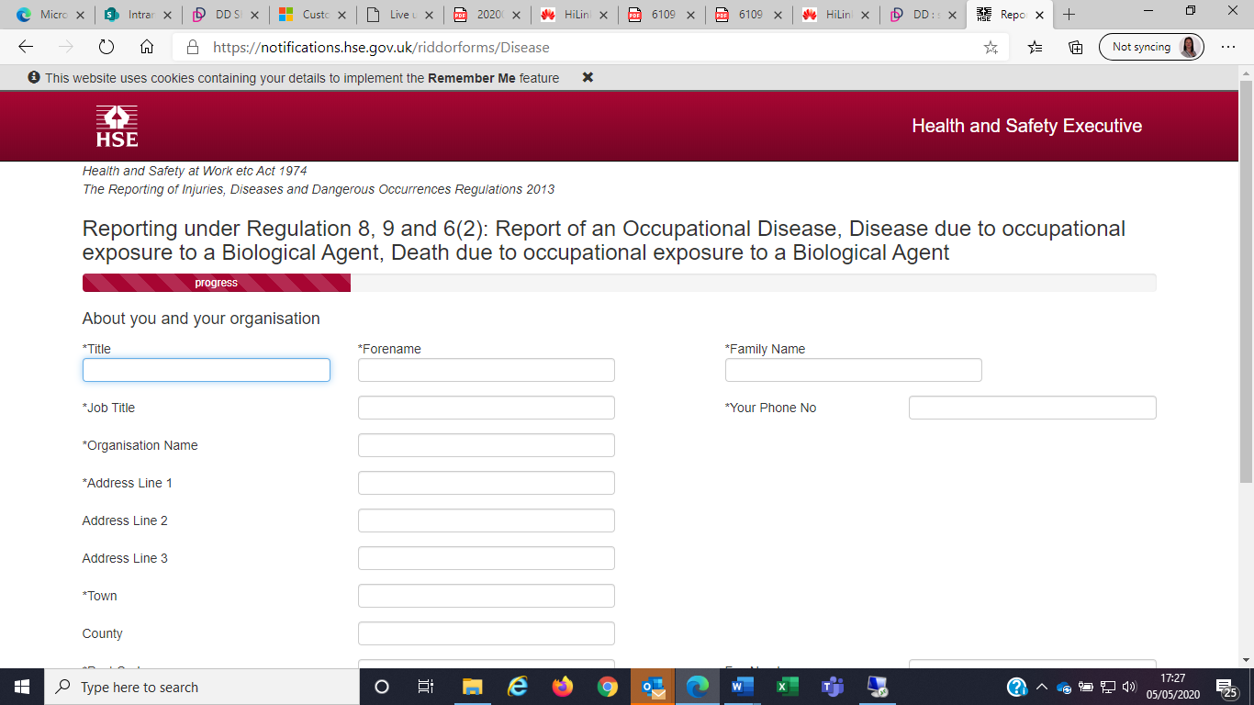

Further guidance is available via: https://www.hse.gov.uk/riddor/reportable-incidents.htm

